

6th Grade Supply List
2023-2024

Personal Supplies for all classes

- backpack (larger size; can have wheels if desired)
- pencil pouch
- pencils
- loose leaf paper
- colored pencils (small pack)
- glue sticks (small pack)
- scissors (smaller pair)
- Markers (small pack)
- Earbuds (cheap pair is just fine.)
- TI 30 XS Multiview Calculator
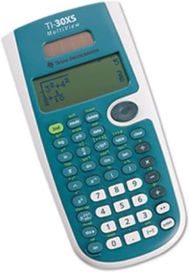

Supplies to be turned in to Homeroom Teacher: not required but very much appreciated.

- 3 boxes of Kleenex
- 2 rolls of paper towels
- 1 canister of disinfecting wipes
- 1 bottle of hand sanitizer

Please Note:
Other supplies may be requested by individual teachers after school begins.

